

**UNIVERSITY OF PETROLEUM AND ENERGY STUDIES**

**School of Computer** **Science**

**2020-21**

**GRAPHICS AND ANIMATION TOOLS LAB**

**Faculty: Dr. DURGANSH SHARMA**

**Assistant Professor**

**Department of Cybernetics.**

**School of Computer Science, UPES**

**Submitted By:**

**Name- Garima Dhall**

**Roll no-R100217025**

**Batch-B1**

**Semester- 7**

**Course-B.tech. CSE-OSOS**

**Sap Id- 500062498**

**EXPERIMENT NO 7**

**Aim** :- Design of 3D Rocket using Blender.

**Objective** :- To Design a 3D Rocket using features of Blender 2.8 .

**STEPS TO MAKE DESIGN A 3D ROCKET:-**

1. Open Blender workspace delete the existing cube and Click on the add option and add cylinder and set it’s vertices as 12 m and cap fill type nothing and then open it in edit mode and scale the cylinder along the length

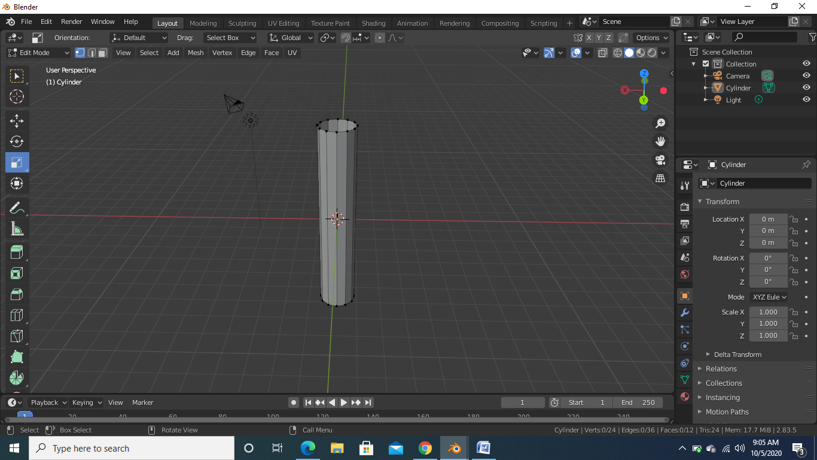

1. Then we will press shift z to make the cylinder wireframe select the number 7 on the number pad and top view gets open after that we will remove the ¾ portion of the circle using command delete->vertices

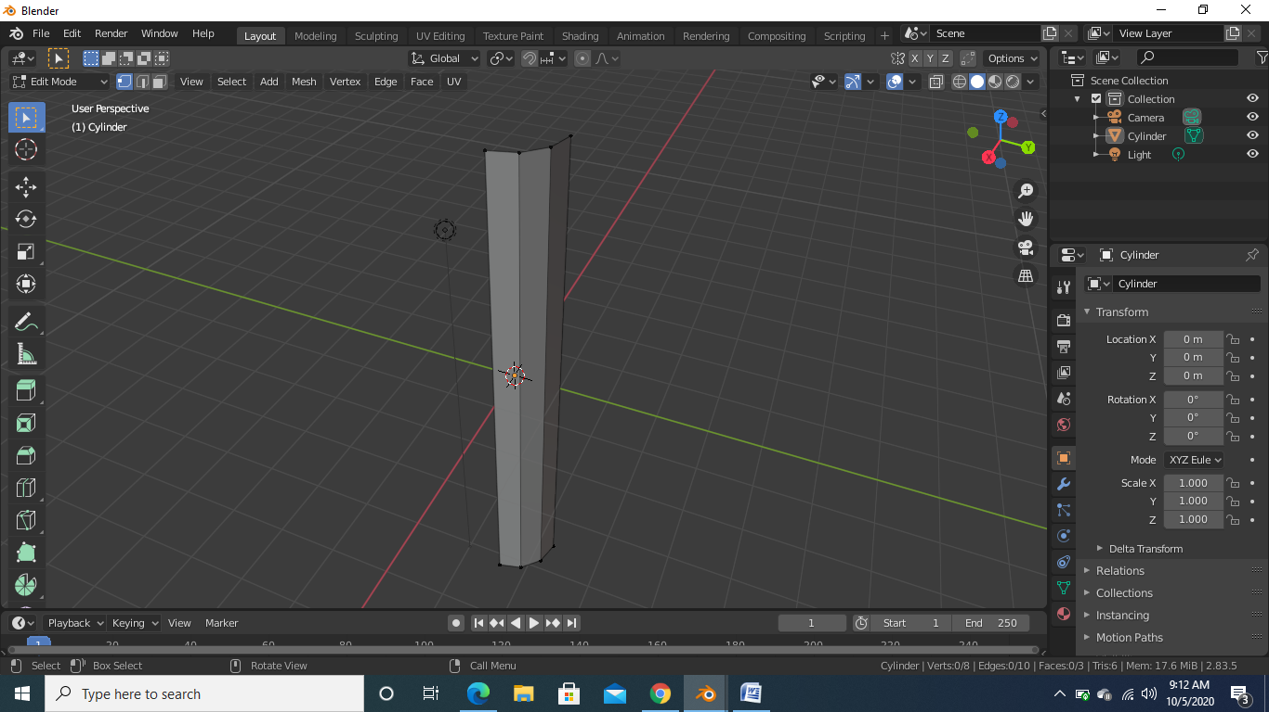

1. After doing the above step we will add mirror modifier along x and y axis and choose clipping option also and we will also add subdivision surface modifier

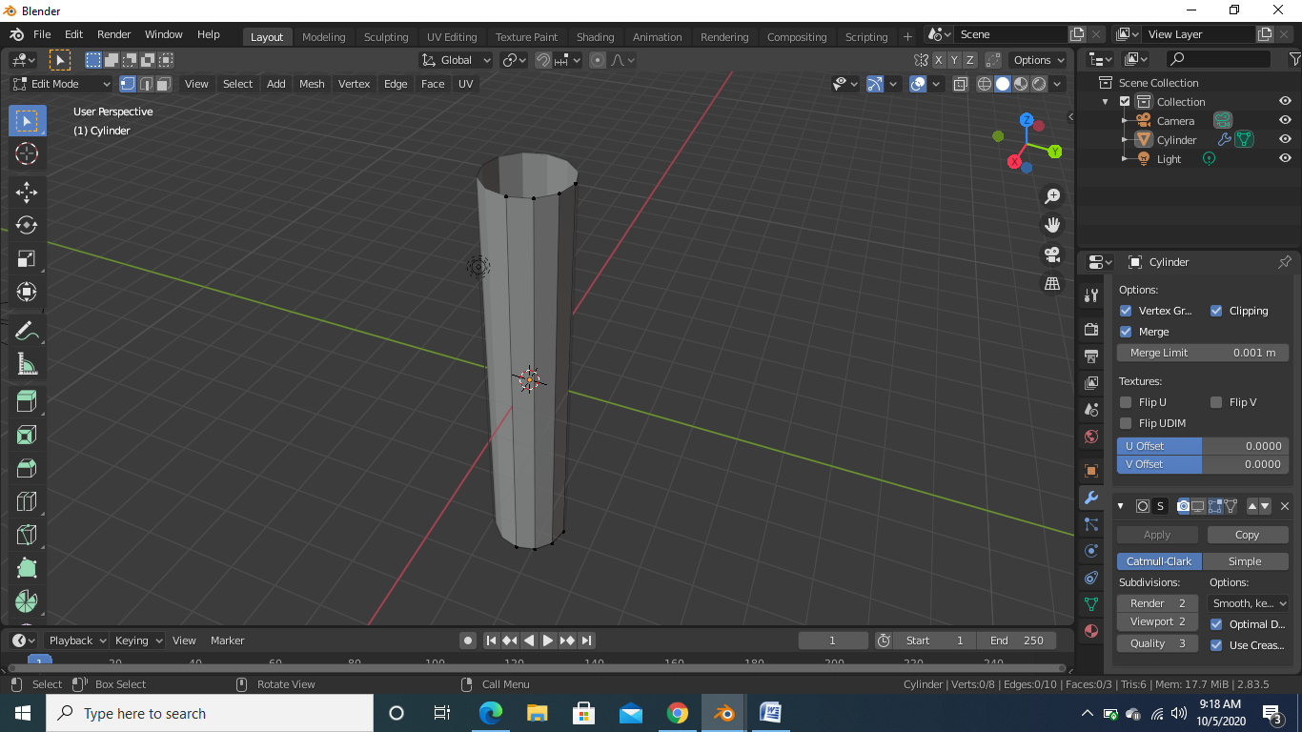

1. After the above step we will add the loop cut at the top and bottom and we will select the one face of the cylinder and then we will press i on keyboard to adjust the inside face extrude that face and scale it in such a manner that it looks like fins of the rocket the same we will do at the bottom portion of the rocket

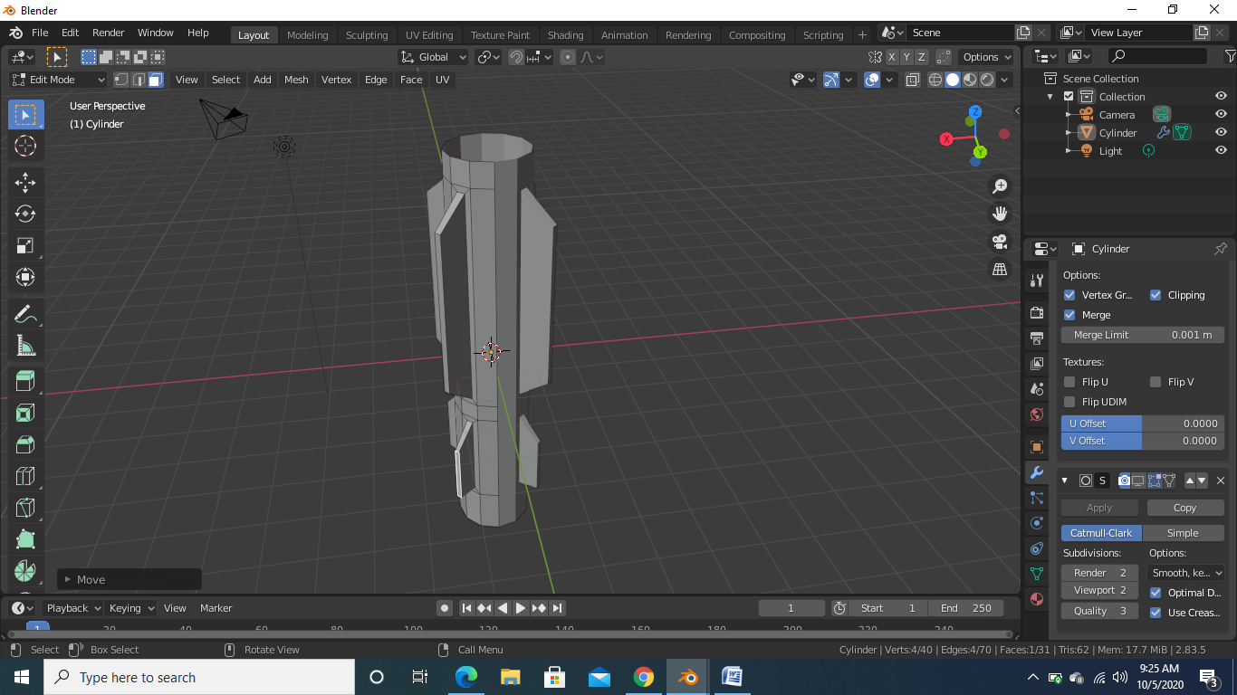

1. After the above step now we will select the vertices of the top face and then we will extrude it along the z axis

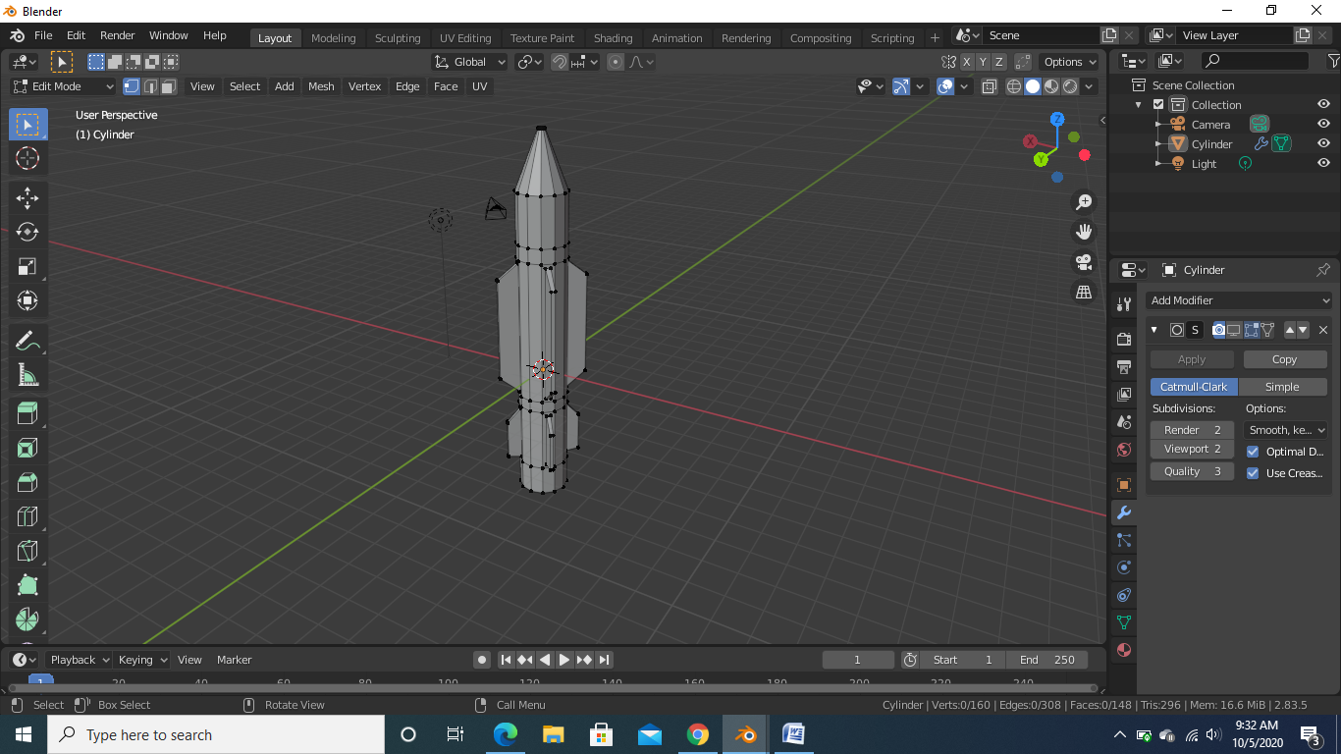

1. After the above step we will select each loop cut and mark it seam

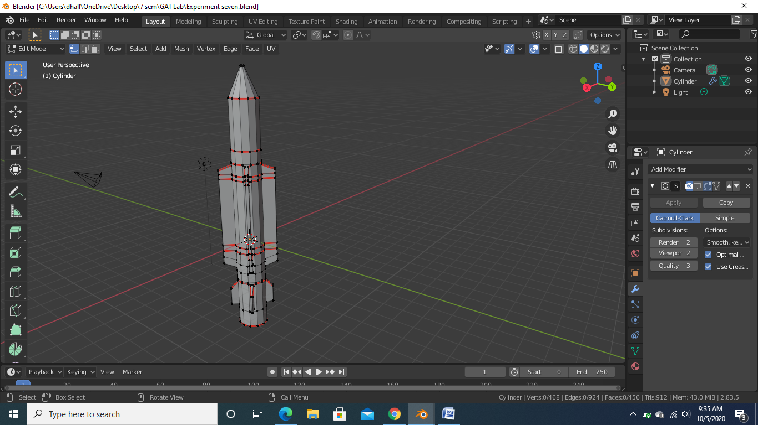

1. Then we will open it in UV editing mode and we will select the whole model and choose new image and after that we will open the texture mode and we will start giving the texture to the surface After giving texture we will open the shade editor and assign the camouflage look and assign the light points

